LAB-3

#include <stdio.h>

#include <stdbool.h>

#define MAX_PROCESSES 10

struct Process {

int pid;

int arrival_time;

int burst_time;

int priority;

int remaining_time;

int turnaround_time;

int waiting_time;

};

void sjf_nonpreemptive(struct Process processes[], int n) {

int i,j,count=0,m;

for(i=0;i<n;i++)

{

if(processes[i].arrival_time==0)

count++;

}

if(count==n||count==1)

{

if(count==n)

{

for (i = 0; i < n - 1; i++) {

for (j = 0; j < n - i - 1; j++) {

if (processes[j].burst_time > processes[j + 1].burst_time) {

struct Process temp = processes[j];

processes[j] = processes[j + 1];

processes[j + 1] = temp;

}

}

}

}

else

{

for (i = 1; i < n - 1; i++) {

for (j = 1; j <= n - i - 1; j++) {

if (processes[j].burst_time > processes[j + 1].burst_time) {

struct Process temp = processes[j];

processes[j] = processes[j + 1];

processes[j + 1] = temp;

}

}

}

}

}

int total_time = 0;

double total_turnaround_time = 0;

double total_waiting_time = 0;

for (i = 0; i < n; i++) {

total_time += processes[i].burst_time;

processes[i].turnaround_time = total_time - processes[i].arrival_time;

processes[i].waiting_time = processes[i].turnaround_time - processes[i].burst_time;

total_turnaround_time += processes[i].turnaround_time;

total_waiting_time += processes[i].waiting_time;

}

printf("Process\tTurnaround Time\tWaiting Time\n");

for (i = 0; i < n; i++) {

printf("%d\t%d\t\t%d\n", processes[i].pid, processes[i].turnaround_time, processes[i].waiting_time);

}

printf("Average Turnaround Time: %.2f\n", total_turnaround_time / n);

printf("Average Waiting Time: %.2f\n", total_waiting_time / n);

}

void sjf_preemptive(struct Process processes[], int n) {

int total_time = 0,i;

int completed = 0;

while (completed < n) {

int shortest_burst = -1;

int next_process = -1;

for (i = 0; i < n; i++) {

if (processes[i].arrival_time <= total_time && processes[i].remaining_time > 0) {

if (shortest_burst == -1 || processes[i].remaining_time < shortest_burst) {

shortest_burst = processes[i].remaining_time;

next_process = i;

}

}

}

if (next_process == -1) {

total_time++;

continue;

}

processes[next_process].remaining_time--;

total_time++;

if (processes[next_process].remaining_time == 0) {

completed++;

processes[next_process].turnaround_time = total_time - processes[next_process].arrival_time;

processes[next_process].waiting_time = processes[next_process].turnaround_time - processes[next_process].burst_time;

}

}

double total_turnaround_time = 0;

double total_waiting_time = 0;

printf("Process\tTurnaround Time\tWaiting Time\n");

for (i = 0; i < n; i++) {

printf("%d\t%d\t\t%d\n", processes[i].pid, processes[i].turnaround_time, processes[i].waiting_time);

total_turnaround_time += processes[i].turnaround_time;

total_waiting_time += processes[i].waiting_time;

}

printf("Average Turnaround Time: %.2f\n", total_turnaround_time / n);

printf("Average Waiting Time: %.2f\n", total_waiting_time / n);

}

void priority_nonpreemptive(struct Process processes[], int n) {

int i,j,count=0,m;

for(i=0;i<n;i++)

{

if(processes[i].arrival_time==0)

count++;

}

if(count==n||count==1)

{

if(count==n)

{

for (i = 0; i < n - 1; i++) {

for (j = 0; j < n - i - 1; j++) {

if (processes[j].priority > processes[j + 1].priority) {

struct Process temp = processes[j];

processes[j] = processes[j + 1];

processes[j + 1] = temp;

}

}

}

}

else

{

for (i = 1; i < n - 1; i++) {

for (j = 1; j <= n - i - 1; j++) {

if (processes[j].priority > processes[j + 1].priority) {

struct Process temp = processes[j];

processes[j] = processes[j + 1];

processes[j + 1] = temp;

}

}

}

}

}

int total_time = 0;

double total_turnaround_time = 0;

double total_waiting_time = 0;

for (i = 0; i < n; i++) {

total_time += processes[i].burst_time;

processes[i].turnaround_time = total_time - processes[i].arrival_time;

processes[i].waiting_time = processes[i].turnaround_time - processes[i].burst_time;

total_turnaround_time += processes[i].turnaround_time;

total_waiting_time += processes[i].waiting_time;

}

printf("Process\tTurnaround Time\tWaiting Time\n");

for (i = 0; i < n; i++) {

printf("%d\t%d\t\t%d\n", processes[i].pid, processes[i].turnaround_time, processes[i].waiting_time);

}

printf("Average Turnaround Time: %.2f\n", total_turnaround_time / n);

printf("Average Waiting Time: %.2f\n", total_waiting_time / n);

}

void priority_preemptive(struct Process processes[], int n) {

int total_time = 0,i;

int completed = 0;

while (completed < n) {

int highest_priority = -1;

int next_process = -1;

for (i = 0; i < n; i++) {

if (processes[i].arrival_time <= total_time && processes[i].remaining_time > 0) {

if (highest_priority == -1 || processes[i].priority < highest_priority) {

highest_priority = processes[i].priority;

next_process = i;

}

}

}

if (next_process == -1) {

total_time++;

continue;

}

processes[next_process].remaining_time--;

total_time++;

if (processes[next_process].remaining_time == 0) {

completed++;

processes[next_process].turnaround_time = total_time - processes[next_process].arrival_time;

processes[next_process].waiting_time = processes[next_process].turnaround_time - processes[next_process].burst_time;

}

}

double total_turnaround_time = 0;

double total_waiting_time = 0;

printf("Process\tTurnaround Time\tWaiting Time\n");

for (i = 0; i < n; i++) {

printf("%d\t%d\t\t%d\n", processes[i].pid, processes[i].turnaround_time, processes[i].waiting_time);

total_turnaround_time += processes[i].turnaround_time;

total_waiting_time += processes[i].waiting_time;

}

printf("Average Turnaround Time: %.2f\n", total_turnaround_time / n);

printf("Average Waiting Time: %.2f\n", total_waiting_time / n);

}

int main() {

int n, quantum,i,choice;

struct Process processes[MAX_PROCESSES];

printf("Enter the number of processes: ");

scanf("%d", &n);

for (i = 0; i < n; i++) {

printf("Process %d\n", i + 1);

printf("Enter arrival time: ");

scanf("%d", &processes[i].arrival_time);

printf("Enter burst time: ");

scanf("%d", &processes[i].burst_time);

processes[i].pid = i + 1;

processes[i].remaining_time = processes[i].burst_time;

processes[i].turnaround_time = 0;

processes[i].waiting_time = 0;

}

while(1){

printf("\nSelect a scheduling algorithm:\n");

printf("1. SJF Non-preemptive\n");

printf("2. SRTF Preemptive\n");

printf("3. Priority Non-preemptive\n");

printf("4. Priority Preemptive\n");

printf("5. Exit\n");

printf("Enter your choice: ");

scanf("%d", &choice);

switch (choice) {

case 1:

printf("\nSJF Non-preemptive Scheduling:\n");

sjf_nonpreemptive(processes, n);

break;

case 2:

printf("\nSJTF Preemptive Scheduling:\n");

sjf_preemptive(processes, n);

break;

case 3:

for (i = 0; i < n; i++) {

printf("Process %d\n", i + 1);

printf("Enter priority: ");

scanf("%d", &processes[i].priority);

}

printf("\nPriority Non-preemptive Scheduling:\n");

priority_nonpreemptive(processes, n);

break;

case 4:

for (i = 0; i < n; i++) {

printf("Process %d\n", i + 1);

printf("Enter priority: ");

scanf("%d", &processes[i].priority);

}

printf("\nPriority Preemptive Scheduling:\n");

priority_preemptive(processes, n);

break;

case 5:exit(0);

break;

default:

printf("Invalid choice!\n");

return 1;

}

}

return 0;

}

OUTPUT:

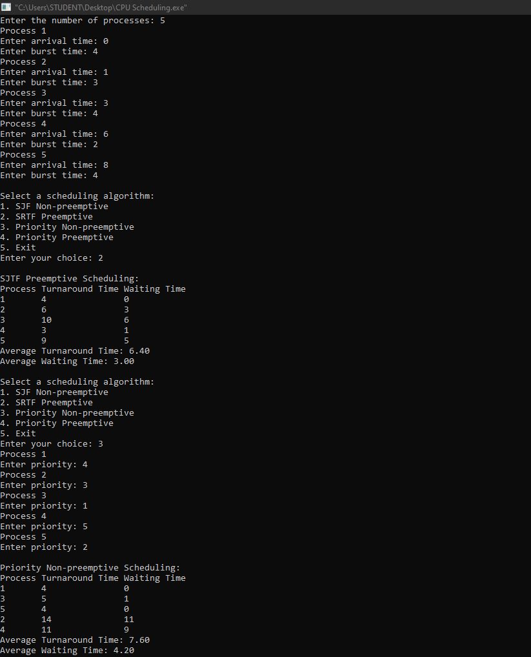

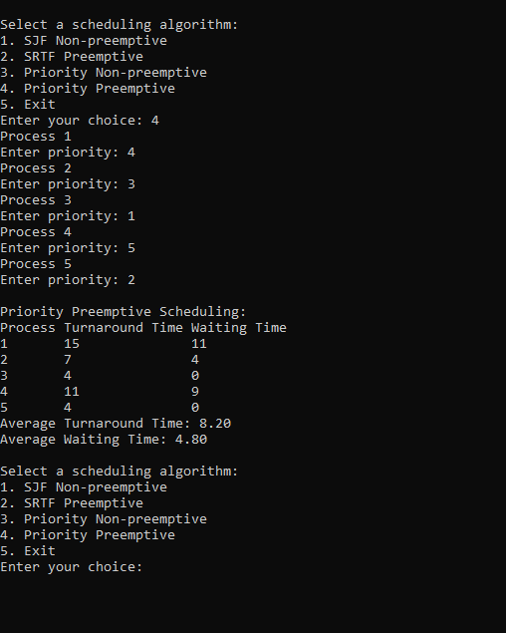

**ROUND ROBIN:**

#include<stdio.h>

#include<limits.h>

#include<stdbool.h>

struct P{

int AT,BT,ST[20],WT,FT,TAT,pos;

};

int quant;

int main(){

int n,i,j;

printf("Enter the no. of processes :");

scanf("%d",&n);

struct P p[n];

printf("Enter the quantum \n");

scanf("%d",&quant);

printf("Enter the process numbers \n");

for(i=0;i<n;i++)

scanf("%d",&(p[i].pos));

printf("Enter the Arrival time of processes \n");

for(i=0;i<n;i++)

scanf("%d",&(p[i].AT));

printf("Enter the Burst time of processes \n");

for(i=0;i<n;i++)

scanf("%d",&(p[i].BT));

int c=n,s[n][20];

float time=0,mini=INT_MAX,b[n],a[n];

int index=-1;

for(i=0;i<n;i++){

b[i]=p[i].BT;

a[i]=p[i].AT;

for(j=0;j<20;j++){

s[i][j]=-1;

}

}

int tot_wt,tot_tat;

tot_wt=0;

tot_tat=0;

bool flag=false;

while(c!=0){

mini=INT_MAX;

flag=false;

for(i=0;i<n;i++){

float p=time+0.1;

if(a[i]<=p && mini>a[i] && b[i]>0){

index=i;

mini=a[i];

flag=true;

}

}

if(!flag){

time++;

continue;

}

j=0;

while(s[index][j]!=-1){

j++;

}

if(s[index][j]==-1){

s[index][j]=time;

p[index].ST[j]=time;

}

if(b[index]<=quant){

time+=b[index];

b[index]=0;

}

else{

time+=quant;

b[index]-=quant;

}

if(b[index]>0){

a[index]=time+0.1;

}

if(b[index]==0){

c--;

p[index].FT=time;

p[index].WT=p[index].FT-p[index].AT-p[index].BT;

tot_wt+=p[index].WT;

p[index].TAT=p[index].BT+p[index].WT;

tot_tat+=p[index].TAT;

}

}

printf("Process number ");

printf("Arrival time ");

printf("Burst time ");

printf("\tStart time");

j=0;

while(j!=10){

j+=1;

printf(" ");

}

printf("\t\tFinal time");

printf("\tWait Time ");

printf("\tTurnAround Time \n");

for(i=0;i<n;i++){

printf("%d \t\t",p[i].pos);

printf("%d \t\t",p[i].AT);

printf("%d \t",p[i].BT);

j=0;

int v=0;

while(s[i][j]!=-1){

printf("%d ",p[i].ST[j]);

j++;

v+=3;

}

while(v!=40){

printf(" ");

v+=1;

}

printf("%d \t\t",p[i].FT);

printf("%d \t\t",p[i].WT);

printf("%d \n",p[i].TAT);

}

double avg_wt,avg_tat;

avg_wt=tot_wt/(float)n;

avg_tat=tot_tat/(float)n;

printf("The average wait time is : %lf\n",avg_wt);

printf("The average TurnAround time is : %lf\n",avg_tat);

return 0;

}

OUTPUT:

